Story Sequencing Task-First Grade
Are you ready? Ok!
Start timer; end task at 8 minutes and help child complete if needed

Teaching: Making Cookies

This story is about a man named Tom who is making cookies. Set out written story cards in correct order and read them {point}. First, Tom mixes it. Next he cuts the cookies. Then he bakes the cookies. Last he puts frosting on the cookies. Spread picture cards out in random order on the table in front of the child. Here are the pictures to go with the story. I want you to match the pictures to the story. Let’s read it again.

{Point}First, Tom mixes it. Next he cuts the cookies. Then he bakes the cookies. Last he puts frosting on the cookies. [Child may match while you read. If so, skip the next step.]
Now match each picture to show the beginning, middle, and end of the story.

[If child does not follow directions, say, “Let’s read the story again. ‘First, Tom mixes it.’ Which picture shows Tom holding the bowl?’” Continue to next card, continue as needed].

Once child has all the pictures matched, say “Nice job” and move to next story.

Independent: Snowman Story

This story is about Lisa and her Dad making a snowman. Hand picture cards to child (in wrong order). First, I want you to put the picture cards in order from beginning, middle to end to make a story.
If picture cards are incorrect, say:
Are you sure those are in the right order?

(If needed:) I don’t think those are in the right order. Think about what the story is about and what happens in the beginning, middle and end and try again.

Once picture cards are correctly completed:
{Slide picture cards up} Now here are the word cards that go along with the pictures. But, it looks like the cards are all mixed up. Let’s see what they say:

They put on the arms.
Lisa puts a snowball on top.
The snowman gets a hat.
Lisa and Dad make a big snowball.
They give the snowman a face.

Spread word cards out in random order on the table in front of the child as they’re read. Now let’s put them in order from beginning, middle to end to match the pictures. If you need me to read a card, you can ask me. Let me know when you’re done.

If word cards are incorrect, say:
Are you sure those are in the right order? I don’t think those are in the right order. Let’s read the story again and see what we need to change.

Once child has placed all the cards (written story and picture cards):
Are you done?

If correct, say Nice job, you worked hard on that.

If incorrect, Are you sure those are in the right order? I don’t think they’re in the right order. Let’s read the story again and see what we need to change. Read each card left to right. Think about what happens in the beginning, middle and end of the story and try again.

If child is not responding, seems to be having trouble or asks for help:
Do you need help?
What do you need help with?
- What are they doing in this picture?
- Does that come before or after this one?
- Do you want me to read that card?

Once child has all the pictures matched, say Nice job, you worked hard on that.

Chores Story

Now I’m going to read you a story about a boy doing his chores. Listen first and then I’ll give you some pictures that go with the story to put in order. AJ has to get all of his chores done so he can go play at the park.

First, his Mom gave him a list of chores to do.
AJ starts with making his bed.
Next, he uses the broom to sweep around the house.
Then he takes out the trash.
Now he is finished and can go play at the park.

Spread the picture cards out in random order on the table in front of the child.

Here are pictures of the chores AJ has to do. Put the pictures in order from beginning to middle to end.

If the child seems confused or unable to get started, say:
I’ll read the story again, and you put the pictures in order from beginning to middle to end. Read the story again, stopping for 5 seconds after each sentence to give the child time to find the picture.

Once child has placed all the cards:
Are you done?

If correct, say Nice job, you worked hard on that.

If incorrect, Are you sure those are in the right order? I don’t think they’re in the right order. Let’s read the story again and listen to what happens in the beginning, middle and end of the story and try again. Read the story again, pausing for 10 seconds after each sentence to give the child time to find the picture.

If child is not responding, seems to be having trouble or asks for help:
Do you need help?
What do you need help with?
Do you want me to read the story again?
- What are they doing in this picture?
- What chore is AJ doing in this picture? Does it come before or after this chore?

Once child has all the pictures matched, say Nice job, you worked hard on that.

Taking a Bath Story

Now I have a story about Bobby taking a bath.

Spread both word and picture cards out in front of the child, in incorrect order.

Here are the story cards and the picture cards. I want you to put them in order from beginning to middle to end to make a story about Bobby taking a bath. If you need me to read a card, you can ask me. Let me know when you’re done.

If the child seems confused or unable to get started, say:
Start by putting the pictures in order to tell a story. Which picture comes first?
- Keep prompting as needed to get response: Which one is next?

If still having trouble, once child has lined up all the pictures, whether correct or not, say,
Now match the story cards to the picture cards.
- If it is evident that the child cannot read the cards or is having real difficulty doing so, say: I’ll read the cards and you tell me which picture they go with.

Once child has placed all the cards (written story and picture cards):
Are you done?

If correct, say Nice job, you worked hard on that. -End Task-

If incorrect, Are you sure those are in the right order? I don’t think they’re in the right order. Let’s read the story again and see what we need to change. Read each card left to right. Think about what happens in the beginning, middle and end of the story and try again.

If child is not responding, seems to be having trouble or asks for help:
Do you need help?
What do you need help with?
- What is he doing in this picture?
- Does that come before or after this one?
- Do you want me to read that card?

Once child has all the pictures matched, say Nice job, you worked hard on that. -End Task-

Correct Story:
Bobby is dirty.
He walks in the bathroom.
He turns on the water.
He gets in the bath.
He washes with soap.
Bobby is clean.

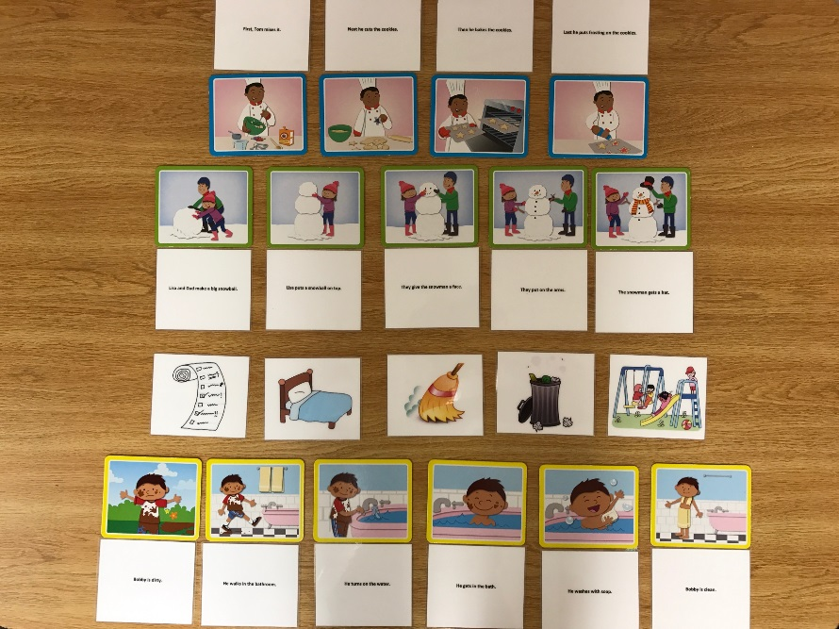

Figure 1. First grade (6 year) story cards. From top to bottom: Training (4-card story, word cards followed by picture cards), trial 1 (5-card story: picture cards followed by word cards), trial 2 (narrated 5-card story), trial 3 (6-card story, word and picture cards given together).

