Tangrams Task-Kindergarten
Are you ready? Ok!
Start timer; end task at10 minutes; help child complete if they are still working on a puzzle.
Now we are going to do an activity with shapes. Here are some shapes: two big triangles, a medium triangle, two small triangles, a square, and a parallelogram {lay shapes flat on table in front of child as introducing them}.

Teaching: {pull out house} Look! These shaped blocks fit into these pictures of shapes. {Demonstrate square} Sometimes you have to turn shapes around to make them fit. {Flip the small triangle} But you see this shape here {show child parallelogram}, this is a tricky shape. To fit this shape into its space, you need to do more than turn the shape around {demonstrate}, you also need to flip it over like this {demonstrate}. Now I want you to fit these blocks into their shape on the paper to make this house {remove all shapes and flip parallelogram back over to original position; let child complete}.

Now, I am going to show you how we can make different, bigger shapes from smaller shapes. {pull out rectangle} See, I can take these two triangles and make a square {demonstrate for child by putting two big triangles together to fit big square outline}. Now you try it {hand child two big triangles, allow child to complete}. Look at that you made a square {point} from two triangles {point}. Now complete the rest of the picture by matching the shapes like you did before. {let child complete}. Nice job.

Tangrams with one line missing: You can make a lot of different shapes and pictures with all these shapes.
Here is another shape, {pull out diamond} with a line is missing. There are still some shapes that you can match {point}; but remember, for some you have to put two shapes together to make a bigger shape. If you need help you can ask me. Tell me when you’re done. {Let child complete; follow prompts if child does not respond, says “I don’t know,” or asks for help and follow same sequence if child finishes incorrectly}.
If child completes correctly: Nice job. {move shapes off page and mix up; flip parallelogram over}
If child is off task, wait 15 seconds, then redirect by saying: Finish the puzzle {child}

{pull out boat }Now, here is another shape we can do. There is still one line missing. Remember if you need help, you can ask me. Tell me when you’re done. {Let child complete; follow prompts if child does not respond, says “I don’t know,” or asks for help and follow same sequence if child finishes incorrectly}.
If child completes correctly: Nice job. {move shapes off page and mix up; flip parallelogram over}

Tangrams with missing lines:
{pull out fish}Now, here’s a shape with three lines missing. Remember if you need help, you can ask me. Tell me when you’re done. {Let child complete; follow prompts if child does not respond, says “I don’t know,” or asks for help and follow same sequence if child finishes incorrectly}.
If child completes correctly: Nice job. {move shapes off page and mix up; flip parallelogram over}

{pull out square} Now I want you to do this square. Remember if you need help you can ask me. Tell me when you’re done. {Let child complete; follow prompts if child does not respond, says “I don’t know,” or asks for help, and follow same sequence if child finishes incorrectly}.
If child completes correctly: Nice job. {move shapes off page and mix up; flip parallelogram over}

{pull out quadrilateral}Now, here is another shape we can do. Remember if you need help, you can ask me. Tell me when you’re done. {Let child complete; follow prompts if child does not respond, says “I don’t know,” or asks for help and follow same sequence if child finishes incorrectly}.
If child completes correctly: Nice job. {move shapes off page and mix up; flip parallelogram over}.

Tangrams with no lines: Now we are going to do something else. I want you to complete this shape {pull out shape 6}, but this picture doesn’t have any lines on it. You have to figure out where the pieces go even though there are no lines. If you need help, you can ask me. Tell me when you’re done. {Let child complete; follow prompts if child does not respond, says “I don’t know,” or asks for help, and follow same sequence if child finishes incorrectly}.
If child completes correctly: Nice job. {move shapes off page and mix up; flip parallelogram over}

-End Task-

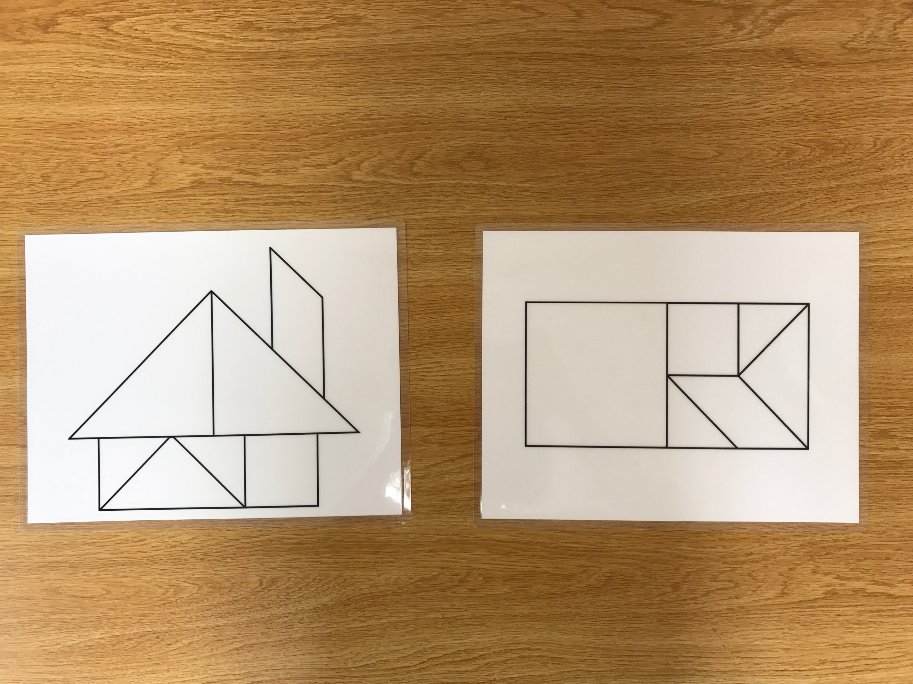
Figure 1. Training puzzles for kindergarten tangrams task. Trials ordered from left to right.

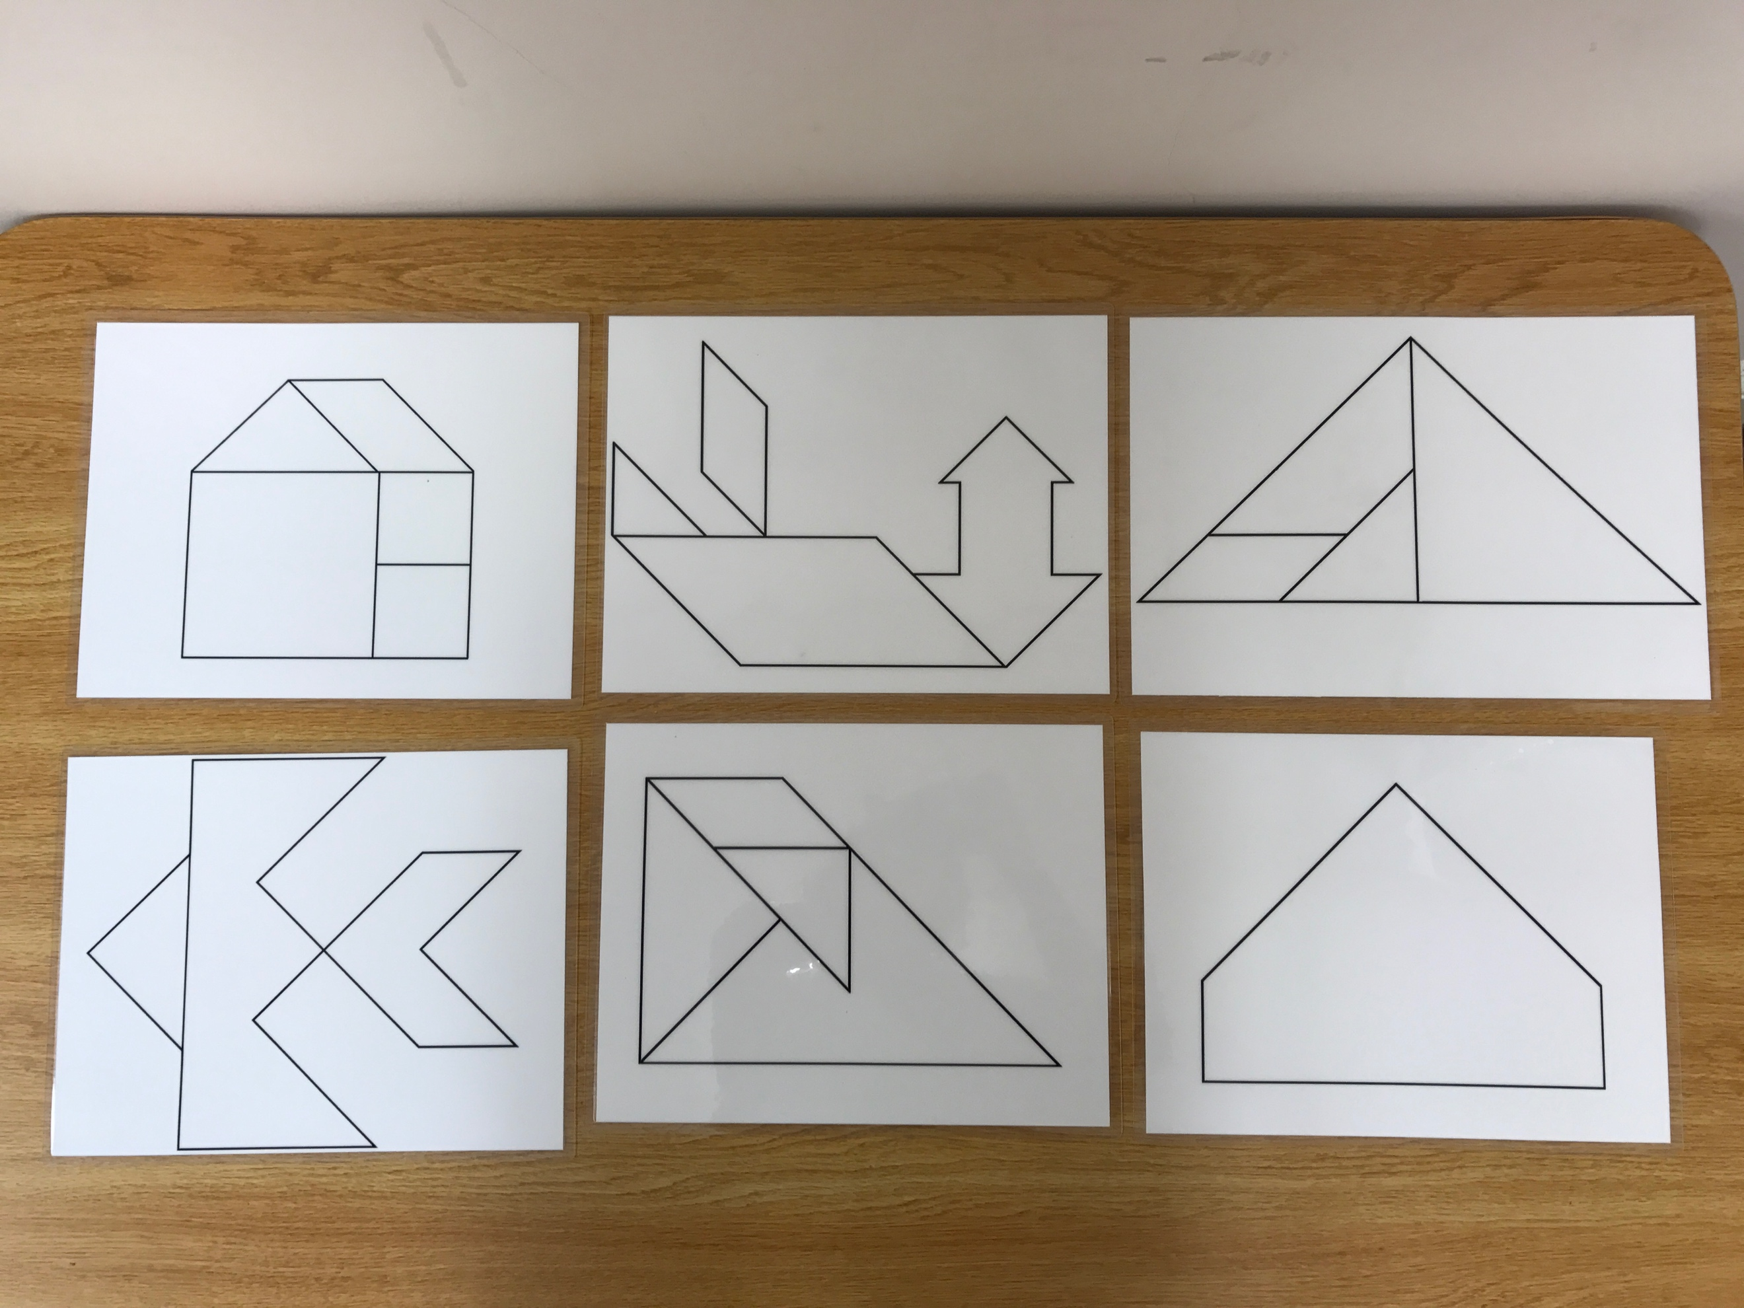
Figure 2. Independent-work puzzles for kindergarten tangrams task. Trials ordered from left to right.

